**Control statements**

**---------------------------**

Allows the flow of execution

If-statement

—----------------------

It is a bidirectional branching statement

Syntax:

—------------

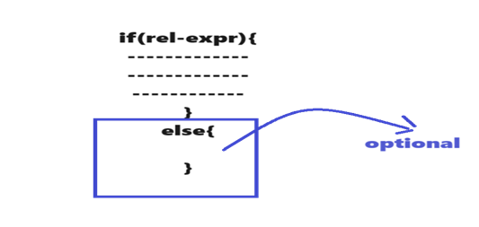

Switch statement

—---------------------

* A multiway branching statement.
* By comparing a variable with multiple constants and execute a specific branch. Based on matching with the constant

Syntax

—-------

switch(variable){

case var1:

----

----

----

break;------> not part of the switch

case var2:

----

----

----

break;

case varn:

----

----

----

break;

default

-------

-------

}

Looping statements

—--------------------------

While-loop and do-while loop are called conditional controlled loops.

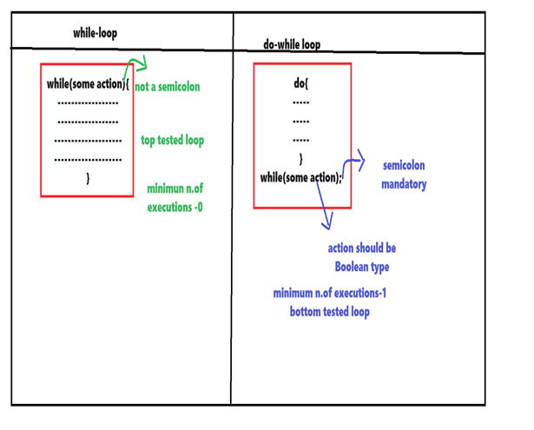

For-loop is called counter controller loops.

For-loop

—-------

Syntax

—-------

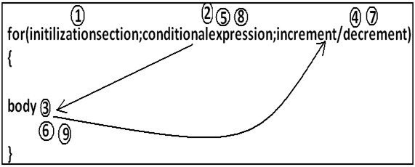

Break statement

—----------------------

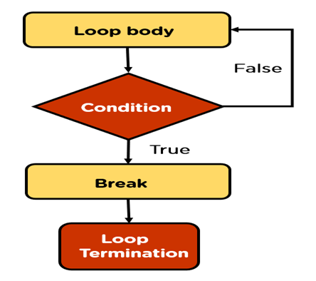

Continue statement

—---------------------------

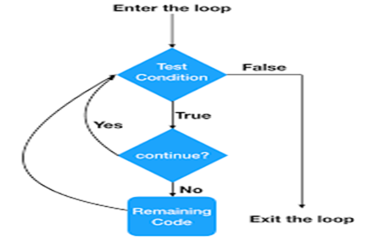

Simple if example

—--------------------------

**package** com.codegnan.controlstatements;

**import** java.util.Scanner;

**public** **class** PositiveNumberExample {

**public** **static** **void** main(String[] args) {

// Create a Scanner object for user input

Scanner scanner = **new** Scanner(System.***in***);

// Prompt the user to enter a number

System.***out***.print("Enter a number: ");

// Read the number entered by the user

**int** number = scanner.nextInt();

// Close the scanner to release resources

scanner.close();

// Check if the number is positive

**if** (number > 0) {

System.***out***.println("The number " + number + " is positive.");

}

}

}

Example-2

—-------------------

**package** com.codegnan.controlstatements;

**import** java.util.Scanner;

**public** **class** WeatherExample {

**public** **static** **void** main(String[] args) {

Scanner scanner = **new** Scanner(System.***in***); // Step 2: Create Scanner object

System.***out***.print("Enter the temperature in Celsius: "); // Prompt user for input

**int** temperature = scanner.nextInt(); // Step 3: Read temperature input

scanner.close(); // Step 5: Close the Scanner object

// Checking if it's a hot day (temperature above 30 degrees Celsius)

**if** (temperature > 30) {

System.***out***.println("It's a hot day. Wear light clothing and drink plenty of water.");

}

// Checking if it's a cold day (temperature below 10 degrees Celsius)

**if** (temperature < 10) {

System.***out***.println("It's a cold day. Wear a thick jacket and gloves.");

}

// Checking if it's a pleasant day (temperature between 10 and 30 degrees Celsius)

**if** (temperature >= 10 && temperature <= 30) {

System.***out***.println("It's a pleasant day. Enjoy your day!");

}

}

}

If-else example

—-------------------

**package** com.codegnan.controlstatements;

**import** java.util.Scanner;

**public** **class** ATMWithdrawalExample {

**public** **static** **void** main(String[] args) {

Scanner scanner = **new** Scanner(System.***in***); // Step 1: Create Scanner object

System.***out***.print("Enter the withdrawal amount: "); // Step 2: Prompt user for input

**double** withdrawalAmount = scanner.nextDouble(); // Step 3: Read withdrawal amount input

**double** accountBalance = 1000.0; // Initial account balance

**if** (withdrawalAmount <= accountBalance) {

accountBalance -= withdrawalAmount;

System.***out***.println("Withdrawal successful. Remaining balance: " + accountBalance);

} **else** {

System.***out***.println("Insufficient funds");

}

scanner.close(); // Step 5: Close the Scanner object

}

}

Example-2

—------------------

**package** com.codegnan.controlstatements;

**import** java.util.Scanner;

**public** **class** PositiveNumberExample {

**public** **static** **void** main(String[] args) {

// Create a Scanner object for user input

Scanner scanner = **new** Scanner(System.***in***);

// Prompt the user to enter a number

System.***out***.print("Enter a number: ");

// Read the number entered by the user

**int** number = scanner.nextInt();

// Close the scanner to release resources

scanner.close();

// Check if the number is positive

**if** (number > 0) {

System.***out***.println("The number " + number + " is positive.");

} **else** {

System.***out***.println("The number " + number + " is either zero or negative.");

}

}

}

Else if-lader example

—-------------------------------

**package** com.codegnan.controlstatements;

**import** java.util.Scanner;

**public** **class** GradeEvaluationExample {

**public** **static** **void** main(String[] args) {

Scanner scanner = **new** Scanner(System.***in***); // Step 1: Create Scanner object

System.***out***.print("Enter the score: "); // Step 2: Prompt user for input

**int** score = scanner.nextInt(); // Step 3: Read score input

// Step 5: Close the Scanner object

scanner.close();

// Evaluating the grade based on the score

**if** (score >= 90) {

System.***out***.println("Grade: A");

} **else** **if** (score >= 80) {

System.***out***.println("Grade: B");

} **else** **if** (score >= 70) {

System.***out***.println("Grade: C");

} **else** {

System.***out***.println("Grade: F");

}

}

}

Example-2 else-if-lader

—--------------------------------

**package** com.codegnan.controlstatements;

**import** java.util.Scanner;

**public** **class** MobilePhonePlanExample {

**public** **static** **void** main(String[] args) {

Scanner scanner = **new** Scanner(System.***in***); // Step 1: Create Scanner object

System.***out***.print("Enter the number of minutes used: "); // Step 2: Prompt user for input

**int** minutesUsed = scanner.nextInt(); // Step 3: Read minutes used input

// Step 5: Close the Scanner object

scanner.close();

// Determine the type of mobile phone plan based on minutes used

**if** (minutesUsed < 100) {

System.***out***.println("You are on the Basic Plan.");

} **else** **if** (minutesUsed < 300) {

System.***out***.println("You are on the Standard Plan.");

} **else** **if** (minutesUsed < 500) {

System.***out***.println("You are on the Premium Plan.");

} **else** {

System.***out***.println("You are on the Unlimited Plan.");

}

}

}

Else if example-3

—--------------------------

3) You are developing a program for a bookstore to calculate the total cost of a book purchase,

including applicable discounts. Create a Java program that calculates the total cost based on the

number of books purchased.

Your task is to write a Java program that takes the number of books purchased as input and

calculates the total cost according to the following criteria:

If the number of books is 1-5: No discount (each book costs $10).

If the number of books is 6-10: 10% discount.

If the number of books is 11-20: 15% discount.

If the number of books is 21 or more: 20% discount.

Input format:

The program should take a single input, which is the number of books purchased (an integer).

Output format:

The program should output the total cost based on the criteria mentioned above.

Code:

package q22398;

import java.util.Scanner;

public class BookDiscountCalculator {

// Method to calculate the total cost based on the number of books

public static double calculateTotalCost(int numberOfBooks) {

double pricePerBook=10.0;

double discount=0.0;

if(numberOfBooks&gt;=1 &amp;&amp; numberOfBooks&lt;=5){

discount=0.0;

}

else if(numberOfBooks&gt;=6 &amp;&amp; numberOfBooks&lt;=10){

discount=0.10;

}

else if(numberOfBooks&gt;=11 &amp;&amp; numberOfBooks&lt;=20){

discount=0.15;

}

else {

discount=0.20;

}

double totalCost=numberOfBooks * pricePerBook;

totalCost -= totalCost*discount;

return totalCost;

}

public static void main(String[] args) {

Scanner scanner = new Scanner(System.in);

System.out.print(&quot;Enter the number of books purchased: &quot;);

int numberOfBooks = scanner.nextInt();

double totalCost = BookDiscountCalculator.calculateTotalCost(numberOfBooks);

System.out.println(&quot;Total Cost: $&quot; + totalCost);

}

}

Switch statement example program

—------------------------------------------------

**package** com.codegnan.controlstatements;

**import** java.util.Scanner;

**public** **class** SwitchExample {

**public** **static** **void** main(String[] args) {

Scanner scanner = **new** Scanner(System.***in***);

System.***out***.println("Enter Day of Week...");

**int** dayName = scanner.nextInt();

**switch** (dayName) {

**default**:

System.***out***.println("please provide day name between 1-7 numbers :");

**case** 1:

System.***out***.println("sunday");

**break**;

**case** 2:

System.***out***.println("Monday");

**case** 3:

System.***out***.println("Tuesday");

**case** 4:

System.***out***.println("Wedneday");

**break**;

**case** 5:

System.***out***.println("thrusday");

**break**;

**case** 6:

System.***out***.println("Friday");

**break**;

**case** 7:

System.***out***.println("Saturday");

**break**;

}

}

}

Example-2

—--------------

**package** com.codegnan.controlstatements;

**import** java.util.Scanner;

**public** **class** VendingMachine {

**public** **static** **void** main(String[] args) {

Scanner scanner = **new** Scanner(System.***in***);

**int** choice;

System.***out***.println("Welcome to the Vending Machine!");

System.***out***.println("Menu:");

System.***out***.println("1. Coke");

System.***out***.println("2. Pepsi");

System.***out***.println("3. Water");

System.***out***.println("4. Snickers");

System.***out***.println("5. Exit");

**do** {

System.***out***.print("Enter your choice (1-5): ");

choice = scanner.nextInt();

**switch** (choice) {

**case** 1:

System.***out***.println("You have selected Coke. Enjoy your drink!");

**break**;

**case** 2:

System.***out***.println("You have selected Pepsi. Enjoy your drink!");

**break**;

**case** 3:

System.***out***.println("You have selected Water. Enjoy your drink!");

**break**;

**case** 4:

System.***out***.println("You have selected Snickers. Enjoy your snack!");

**break**;

**case** 5:

System.***out***.println("Thank you for using the Vending Machine. Have a nice day!");

**break**;

**default**:

System.***out***.println("Invalid choice. Please select a valid option.");

**break**;

}

System.***out***.println(); // Blank line for better readability

} **while** (choice != 5);

scanner.close();

}

}

Example-3

—------------------

**package** com.codegnan.controlstatements;

**import** java.util.Scanner;

**public** **class** ATMExample {

**public** **static** **void** main(String[] args) {

Scanner scanner = **new** Scanner(System.***in***);

**int** balance = 1000; // Initial balance

**int** pin = 1234; // Example PIN

**int** enteredPin;

// Ask for PIN

System.***out***.print("Enter your PIN: ");

enteredPin = scanner.nextInt();

// Validate PIN

**if** (enteredPin != pin) {

System.***out***.println("Incorrect PIN. Exiting...");

**return**;

}

**int** choice;

**do** {

// Display menu

System.***out***.println("ATM Menu:");

System.***out***.println("1. Check Balance");

System.***out***.println("2. Deposit");

System.***out***.println("3. Withdraw");

System.***out***.println("4. Exit");

System.***out***.print("Enter your choice: ");

choice = scanner.nextInt();

// Process the choice using switch case

**switch** (choice) {

**case** 1:

System.***out***.println("Your balance is: $" + balance);

**break**;

**case** 2:

System.***out***.print("Enter amount to deposit: ");

**int** deposit = scanner.nextInt();

**if** (deposit % 100 != 0) {

System.***out***.println("Deposit amount must be a multiple of 100.");

} **else** **if** (deposit < 500) {

System.***out***.println("Deposit amount must be at least 500 rupees.");

} **else** {

balance += deposit;

System.***out***.println("Deposited $" + deposit + ". New balance is: $" + balance);

}

**break**;

**case** 3:

System.***out***.print("Enter amount to withdraw: ");

**int** withdraw = scanner.nextInt();

**if** (withdraw % 100 != 0) {

System.***out***.println("Withdrawal amount must be a multiple of 100.");

} **else** **if** (withdraw < 500) {

System.***out***.println("Withdrawal amount must be at least 500 rupees.");

} **else** **if** (withdraw > balance) {

System.***out***.println("Insufficient funds.");

} **else** {

balance -= withdraw;

System.***out***.println("Withdrew $" + withdraw + ". New balance is: $" + balance);

}

**break**;

**case** 4:

System.***out***.println("Exiting... Thank you for using the ATM.");

**break**;

**default**:

System.***out***.println("Invalid choice. Please choose a valid option.");

**break**;

}

} **while** (choice != 4);

scanner.close();

}

}

Example 4:

—--------------

### **Java Program for Arithmetic Operations Using Switch Case**

import java.util.Scanner;

public class ArithmeticOperations {

public static void main(String[] args) {

Scanner scanner = new Scanner(System.in);

// Input two numbers

System.out.print("Enter first number: ");

double num1 = scanner.nextDouble();

System.out.print("Enter second number: ");

double num2 = scanner.nextDouble();

// Input operation choice

System.out.println("Choose an operation:");

System.out.println("1. Addition (+)");

System.out.println("2. Subtraction (-)");

System.out.println("3. Multiplication (*)");

System.out.println("4. Division (/)");

System.out.print("Enter your choice (1/2/3/4): ");

int choice = scanner.nextInt();

// Perform the chosen operation using switch case

double result;

switch (choice) {

case 1:

result = num1 + num2;

System.out.println("Result: " + num1 + " + " + num2 + " = " + result);

break;

case 2:

result = num1 - num2;

System.out.println("Result: " + num1 + " - " + num2 + " = " + result);

break;

case 3:

result = num1 * num2;

System.out.println("Result: " + num1 + " * " + num2 + " = " + result);

break;

case 4:

// Handle division by zero

if (num2 == 0) {

System.out.println("Error: Division by zero is not allowed.");

} else {

result = num1 / num2;

System.out.println("Result: " + num1 + " / " + num2 + " = " + result);

}

break;

default:

System.out.println("Invalid choice. Please enter a number between 1 and 4.");

break;

}

scanner.close();

}

}

Using while loop examples

—---------------------------------

### **. Printing Numbers from 1 to 100**

public class NumbersFrom1To100 {

public static void main(String[] args) {

int i = 1; // Start from 1

while (i <= 100) {

System.out.println(i);

i++; // Increment the counter

}

}

}

### **2. Printing Odd Numbers from 1 to 100**

public class OddNumbersFrom1To100 {

public static void main(String[] args) {

int i = 1; // Start from 1

while (i <= 100) {

if (i % 2 != 0) { // Check if the number is odd

System.out.println(i);

}

i++; // Increment the counter

}

}

}

### **3. Printing Even Numbers from 1 to 100**

public class EvenNumbersFrom1To100 {

public static void main(String[] args) {

int i = 1; // Start from 1

while (i <= 100) {

if (i % 2 == 0) { // Check if the number is even

System.out.println(i);

}

i++; // Increment the counter

}

}

}

Do-while examples

—-------------------------

### **1. Printing Numbers from 1 to 100**

public class NumbersFrom1To100 {

public static void main(String[] args) {

int i = 1; // Start from 1

do {

System.out.println(i);

i++; // Increment the counter

} while (i <= 100);

}

}

### **2. Printing Odd Numbers from 1 to 100**

public class OddNumbersFrom1To100 {

public static void main(String[] args) {

int i = 1; // Start from 1

do {

if (i % 2 != 0) { // Check if the number is odd

System.out.println(i);

}

i++; // Increment the counter

} while (i <= 100);

}

}

### **3. Printing Even Numbers from 1 to 100**

public class EvenNumbersFrom1To100 {

public static void main(String[] args) {

int i = 1; // Start from 1

do {

if (i % 2 == 0) { // Check if the number is even

System.out.println(i);

}

i++; // Increment the counter

} while (i <= 100);

}

}

For-loop examples

—---------------------------

### **1. Printing Numbers from 1 to 100**

public class NumbersFrom1To100 {

public static void main(String[] args) {

for (int i = 1; i <= 100; i++) {

System.out.println(i);

}

}

}

### **2. Printing Odd Numbers from 1 to 100**

public class OddNumbersFrom1To100 {

public static void main(String[] args) {

for (int i = 1; i <= 100; i++) {

if (i % 2 != 0) { // Check if the number is odd

System.out.println(i);

}

}

}

}

### **3. Printing Even Numbers from 1 to 100**

public class EvenNumbersFrom1To100 {

public static void main(String[] args) {

for (int i = 1; i <= 100; i++) {

if (i % 2 == 0) { // Check if the number is even

System.out.println(i);

}

}

}

}

Break statement examples

—----------------------------------

### **1. Printing Numbers from 1 to 100 (with Break Statement)**

public class NumbersFrom1To100 {

public static void main(String[] args) {

for (int i = 1; ; i++) { // Infinite loop, will break manually

if (i > 100) {

break; // Exit the loop when i is greater than 100

}

System.out.println(i);

}

}

}

### **2. Printing Odd Numbers from 1 to 100 (with Break Statement)**

public class OddNumbersFrom1To100 {

public static void main(String[] args) {

int i = 1;

while (true) { // Infinite loop, will break manually

if (i > 100) {

break; // Exit the loop when i is greater than 100

}

if (i % 2 != 0) { // Check if the number is odd

System.out.println(i);

}

i++;

}

}

}

### **3. Printing Even Numbers from 1 to 100 (with Break Statement)**

public class EvenNumbersFrom1To100 {

public static void main(String[] args) {

int i = 1;

do {

if (i > 100) {

break; // Exit the loop when i is greater than 100

}

if (i % 2 == 0) { // Check if the number is even

System.out.println(i);

}

i++;

} while (true); // Infinite loop, will break manually

}

}

Continue examples

—-----------------------------

### **1. Printing Numbers from 1 to 100 (Using continue)**

public class NumbersFrom1To100 {

public static void main(String[] args) {

for (int i = 1; i <= 100; i++) {

// No special condition, just printing numbers

System.out.println(i);

// continue is redundant here, but included for demonstration

continue; // Skip the rest of the loop and proceed to the next iteration

}

}

}

### **2. Printing Odd Numbers from 1 to 100 (Using continue)**

public class OddNumbersFrom1To100 {

public static void main(String[] args) {

for (int i = 1; i <= 100; i++) {

if (i % 2 == 0) {

continue; // Skip the current iteration if i is even

}

System.out.println(i); // Print only odd numbers

}

}

}

### **3. Printing Even Numbers from 1 to 100 (Using continue)**

public class EvenNumbersFrom1To100 {

public static void main(String[] args) {

for (int i = 1; i <= 100; i++) {

if (i % 2 != 0) {

continue; // Skip the current iteration if i is odd

}

System.out.println(i); // Print only even numbers

}

}

}

Factorial of a number program

—--------------------------------------------

**package** com.codegnan.controlstatements;

**import** java.util.Scanner;

**public** **class** FactorialNumber {

**public** **static** **void** main(String[] args) {

Scanner scanner = **new** Scanner(System.***in***);

System.***out***.println("Enter the number : ");

**int** number = scanner.nextInt();

**int** result = 1;

**for** (**int** i = 1; i <= number; i++) {

result = result * i;

}

System.***out***.println("Factorial of " + number + " is : " + result);

}

}

Reverse of a Number program

—-----------------------------------------

**package** com.codegnan.controlstatements;

**import** java.util.Scanner;

**public** **class** ReverseNumber {

**public** **static** **void** main(String[] args) {

Scanner scanner = **new** Scanner(System.***in***);

System.***out***.println("Enter a number : ");

**int** number = scanner.nextInt();

**int** reversedNumber = 0;

**int** originalNumber=number;

**while** (originalNumber != 0) {

**int** remainder = originalNumber % 10;

reversedNumber = reversedNumber * 10 + remainder;

originalNumber = originalNumber / 10;

}

System.out.println("revese of a number : " + number + " is " + reversedNumber);

}

}

Palindrome number

—---------------------------

**package** com.codegnan.controlstatements;

**import** java.util.Scanner;

**public** **class** ReverseNumber {

**public** **static** **void** main(String[] args) {

Scanner scanner = **new** Scanner(System.***in***);

System.***out***.println("Enter a number : ");

**int** number = scanner.nextInt();

**int** reversedNumber = 0;

**int** originalNumber=number;

**while** (originalNumber != 0) {

**int** remainder = originalNumber % 10;

reversedNumber = reversedNumber * 10 + remainder;

originalNumber = originalNumber / 10;

}

//System.out.println("revese of a number : " + number + " is " + reversedNumber);

**if**(number==reversedNumber) {

System.***out***.println(number+" is a palindrome");

}**else** {

System.***out***.println(number+" is not a palindrome ");

}

}

}

Count number of digits program

—--------------------------------------------

**import** java.util.Scanner;

**public** **class** SumOfDigits {

**public** **static** **void** main(String[] args) {

Scanner scanner = **new** Scanner(System.***in***);

System.***out***.println("Enter a number : ");

**int** number = scanner.nextInt();

**int** originalNumber=number;

**int** count = 0;

**int** remainder;

**while** (number != 0) {

number = number / 10;

count++;

}

System.***out***.println("the count digits in a given number " + originalNumber + " is : " + count);

}

}

Sum of digits program

—------------------------------

**package** com.codegnan.controlstatements;

**import** java.util.Scanner;

**public** **class** SumOfDigits {

**public** **static** **void** main(String[] args) {

Scanner scanner = **new** Scanner(System.***in***);

System.***out***.println("Enter a number : ");

**int** number = scanner.nextInt();

**int** originalNumber=number;

**int** sum = 0;

**int** remainder;

**while** (number != 0) {

remainder = number % 10;

sum = sum + remainder;

number = number / 10;

}

System.***out***.println("the sum of digits in a given number " + originalNumber + " is : " + sum);

}

}

Fibonacci series

—--------------------------

**package** com.codegnan.controlstatements;

**import** java.util.Scanner;

**public** **class** FibonacciSeries {

**public** **static** **void** main(String[] args) {

Scanner scanner = **new** Scanner(System.***in***);

System.***out***.println("Enter the Number of Terms in the fibonacci Series : ");

**int** numberOfTerms = scanner.nextInt();

**int** firstTerm = 0;

**int** secondTerm = 1;

System.***out***.println("Fibonacci Series : ");

System.***out***.print(firstTerm + " " + secondTerm+" ");// 0 1 1 2 3 5

**for** (**int** i = 2; i < numberOfTerms; i++) {

**int** nextTerm = firstTerm + secondTerm;//2

System.***out***.print(nextTerm + " ");

firstTerm = secondTerm;//

secondTerm = nextTerm;// =

}

}

}

Armstrong number example

—-----------------------------------------

**package** com.codegnan.arrayprograms;

**import** java.util.Scanner;

**public** **class** ArmstrongNumber {

**public** **static** **void** main(String[] args) {

Scanner scanner = **new** Scanner(System.***in***);

System.***out***.print("Enter a number to check if it's an Armstrong number: ");

**int** number = scanner.nextInt();

**int** originalNumber, remainder, result = 0;

originalNumber = number;

**while** (originalNumber != 0) {

remainder = originalNumber % 10;

result += Math.*pow*(remainder, 3);

originalNumber /= 10;

}

**if** (result == number)

System.***out***.println(number + " is an Armstrong number.");

**else**

System.***out***.println(number + " is not an Armstrong number.");

scanner.close();

}

}